Ex: 04 JSON REPRESENTATION USING JAVASCRIPT Date: 05.01.2026
Name: Ajay Kumar S
Roll no: 2024503701
Aim:
To design JSON representation using JavaScript.
Description:
The webpage is created using various HTML and CSS tags. Below are the tags used along with a short description:
HTML Tags Used:
- <html> – The root element of an HTML page.
- <head> – Contains metadata, title, styles, and links used in the webpage.
- <body> – Contains all the visible content shown on the webpage.
- <h1>, <h2>, <h3>, <h4> – Heading tags used to display titles and subheadings.
- <hr> – Inserts a horizontal line for separation.
- <img> – Used to display images on the webpage.
- <p> – Defines a paragraph of text.
- <a> – Hyperlink tag used to link to external websites.
- <label> – Text associated with form input fields.
- <input> – Used to take user input such as text, number, checkbox, radio, and submit.
- <ul> – Unordered list to display bullet points.
- <ol> – Ordered list to display numbered items.
- <li> – List items inside ul or ol.
- <marquee> – Used to create scrolling text or images (deprecated tag).
- <table> – Used to display data in tabular form.
- <th> – Table header cell.
- <tr> – Table row.
- <td> – Table data cell.
- <form> – Used to create a form for user input.
- <br> – Line break to shift content to the next line.
- <style> – Internal CSS to style HTML elements.

JavaScript Used:

Fetching Data from a JSON File:

- Used the fetch() API to load data.json.
- Converted the response to a JavaScript object using .json().

DOM Manipulation:

- Used document.getElementById() to access HTML elements.
- Created new HTML elements (<tr>) dynamically with document.createElement().
- Updated element content using innerHTML.
- Appended elements to the DOM with appendChild().

Iteration Over Data:

- Used forEach() to loop through arrays (hotels and bookings).
- Event Handling
- Added a submit event listener on the booking form using addEventListener().
- Prevented the default form submission behavior using event.preventDefault().

Form Data Handling:

- Retrieved user input values using .value from form input fields.
- Created a JavaScript object to store booking information.

Web Storage (Session Storage):

- Used sessionStorage.getItem() to retrieve stored data.
- Used sessionStorage.setItem() to save data.
- Parsed JSON strings into objects with JSON.parse() and converted objects back to strings with JSON.stringify().

Dynamic Table Rendering:

- Rendered booking data dynamically in a table.
- Re-rendered the table whenever data changed.

Delete Functionality:

- Filtered out items from an array using Array.filter().
- Updated the table and storage after deleting a booking.
- Defined a global function (window.deleteBooking) to make the delete button work.

Alert Messages:

- Displayed feedback to the user using alert() after a successful booking.

Unique ID Generation:

- Generated unique IDs for bookings using Date.now().

Code:
Index.html:
<!DOCTYPE html>
<html lang="en">
<head>
<meta charset="UTF-8">
<meta name="viewport" content="width=device-width, initial-scale=1.0">
<title>Hotel Management</title>
<link rel="stylesheet" href="style.css">
</head>
<body>
<h1 class="title">Hotel Management System [Ajay Kumar] 2024503701</h1>
<hr>
<div class="homeNav">
<h3><a href="viewHotel.html"> View Hotels </a></h3>
<h3><a href="bookRoom.html"> Book Rooms </a></h3>
<h3><a href="currentBooking.html"> Current Booking </a></h3>
</div>
<marquee direction="right" scrollamount="30">
<img src="img/f.jfif" width="500">
<img src="img/f1.jfif" width="500">
<img src="img/f2.jfif" width="500">
<img src="img/f3.jfif" width="500">
</marquee>
<script src="script.js"></script>
</body>
</html>
bookRoom.html:

<!DOCTYPE html>
<html lang="en">
<head>
<meta charset="UTF-8">
<title>Hotel Booking</title>
</head>
<body>
<link rel="stylesheet" href="style.css">
<h1 class="title">Hotel Room Booking</h1>
<hr>
<form id="bookingForm">
<label>Customer Name</label><br>
<input type="text" id="name" required><br><br>
<label>Phone Number</label><br>
<input type="tel" id="phone" required><br><br>
<label>Email</label><br>
<input type="email" id="email" required><br><br>
<label>Hotel Name</label><br>
<select id="hotel" required>
<option value="">Select Hotel</option>
<option>Sunrise Grand Hotel</option>
<option>Ocean View Resort</option>
<option>Mountain Stay Inn</option>
<option>Royal Palace Hotel</option>
</select><br><br>
<label>Check-in Date</label><br>
<input type="date" id="checkin" required><br><br>
<label>Check-out Date</label><br>
<input type="date" id="checkout" required><br><br>
<label>Number of Guests</label><br>
<input type="number" id="guests" min="1" max="10" required><br><br>
<button type="submit">Book Now</button>
</form>
<h3><a href="currentBooking.html"> Current Booking </a></h3>
<script src="script.js"></script>
</body>
</html>
currentBooking.html:
<!DOCTYPE html>
<html lang="en">
<head>
<meta charset="UTF-8">
<meta name="viewport" content="width=device-width, initial-scale=1.0">
<title>Current Booking</title>
<link rel="stylesheet" href="style.css">
</head>
<body>
<h1 class="title">Currnet Booking Details</h1>
<hr>
<table border="1" class="viewCss">
<thead>
<tr>
<th>Name</th>
<th>Phone</th>
<th>Email</th>
<th>Hotel</th>
<th>Check-in</th>
<th>Check-out</th>
<th>Guests</th>
<th>Action</th>
</tr>
</thead>
<tbody id="bookingTable">
</tbody>
</table>
<script src="script.js"></script>
</body>
</html>
viewHotel.html:
<!DOCTYPE html>
<html lang="en">
<head>
<meta charset="UTF-8">
<meta name="viewport" content="width=device-width, initial-scale=1.0">
<title>Hotel Data</title>
<link rel="stylesheet" href="style.css">
</head>
<body>
<h1 class="title">View Hotels Details</h1>
<hr>
<table border="1" class="viewCss">
<thead>
<tr class="tr">
<th>HotelId</th>
<th>Name</th>
<th>Location</th>
<th>Contact</th>
<th>Ratings</th>
</tr>
</thead>
<tbody id="hotelTable">
</tbody>
</table>
<script src="script.js"></script>
</body>
</html>
Script.js:
fetch('data.json')
.then(response => response.json())
.then(data=>{
const table = document.getElementById('hotelTable');
data.hotels.forEach(element => {
const row = document.createElement('tr');
row.innerHTML = `
<td>${element.hotelId}</td>
<td>${element.name}</td>
<td>${element.location.address} , ${element.location.city},${element.location.country}</td>
<td>${element.contact.phone}, ${element.contact.email}</td>
<td>${element.rating}</td>
`;
table.appendChild(row);
});
})
.catch(err=>console.log("Error : .err"));
const bookingForm = document.getElementById("bookingForm");
if (bookingForm) {
bookingForm.addEventListener("submit", function(e) {
e.preventDefault();
const bookingData = {
id: Date.now(),
name: document.getElementById("name").value,
phone: document.getElementById("phone").value,
email: document.getElementById("email").value,
hotel: document.getElementById("hotel").value,
checkIn: document.getElementById("checkin").value,
checkOut: document.getElementById("checkout").value,
guests: document.getElementById("guests").value
};
let bookings = JSON.parse(sessionStorage.getItem("bookings")) || [];
bookings.push(bookingData);
sessionStorage.setItem("bookings", JSON.stringify(bookings));
alert("Booking added successfully!");
bookingForm.reset();
});
}
const bookingTable = document.getElementById("bookingTable");
if (bookingTable) {

let bookings = JSON.parse(sessionStorage.getItem("bookings")) || [];
function renderTable() {
bookingTable.innerHTML = "";
bookings.forEach((booking) => {
const row = document.createElement("tr");
row.innerHTML = `
<td>${booking.name}</td>
<td>${booking.phone}</td>
<td>${booking.email}</td>
<td>${booking.hotel}</td>
<td>${booking.checkIn}</td>
<td>${booking.checkOut}</td>
<td>${booking.guests}</td>
<td><button onclick="deleteBooking(${booking.id})">Delete</button></td>
`;
bookingTable.appendChild(row);
});
}
renderTable();
// Function to delete booking
window.deleteBooking = function(id) {
bookings = bookings.filter(b => b.id !== id);
sessionStorage.setItem("bookings", JSON.stringify(bookings));
renderTable();
};
}
Data.json:
{
"hotels": [
{
"hotelId": "H1001",
"name": "Sunrise Grand Hotel",
"location": {
"address": "123 Beach Road",
"city": "Miami",
"country": "USA"
},
"contact": {
"phone": "+1-555-123-4567",
"email": "info@sunrisegrand.com"
},
"rating": 4.5
},
{
"hotelId": "H1002",
"name": "Ocean View Resort",
"location": {
"address": "45 Ocean Drive",
"city": "Los Angeles",
"country": "USA"
},
"contact": {
"phone": "+1-555-234-5678",
"email": "contact@oceanview.com"
},
"rating": 4.2
},
{
"hotelId": "H1003",
"name": "Mountain Stay Inn",
"location": {
"address": "78 Hill Road",
"city": "Denver",
"country": "USA"
},
"contact": {
"phone": "+1-555-345-6789",
"email": "support@mountainstay.com"
},
"rating": 4.0
},
{
"hotelId": "H1004",
"name": "Royal Palace Hotel",
"location": {
"address": "12 King Street",
"city": "London",
"country": "UK"
},
"contact": {
"phone": "+44-555-456-7890",
"email": "info@royalpalace.co.uk"
},
"rating": 4.7
},
{
"hotelId": "H1005",
"name": "City Lights Hotel",
"location": {
"address": "88 Downtown Ave",
"city": "New York",
"country": "USA"
},
"contact": {
"phone": "+1-555-567-8901",
"email": "hello@citylights.com"
},
"rating": 4.3
}
]}
Output:

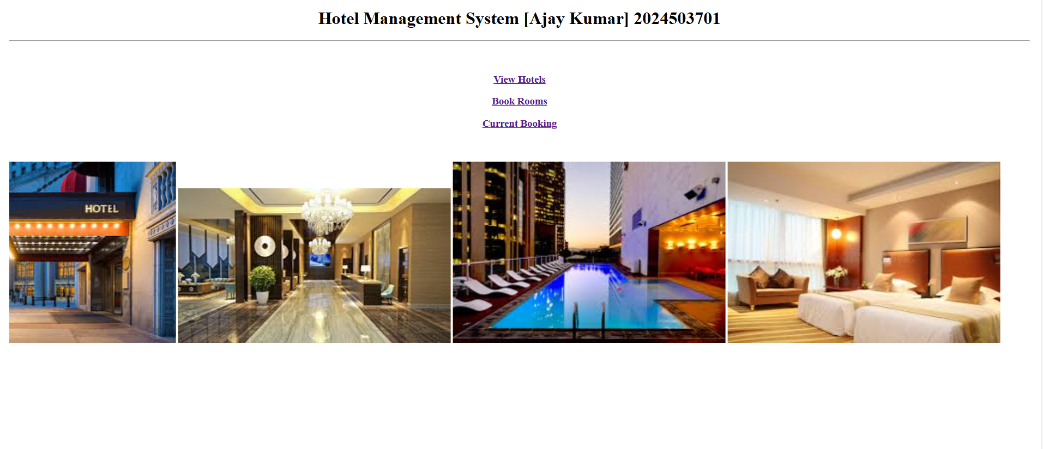
Figure(a) Dashboard Page

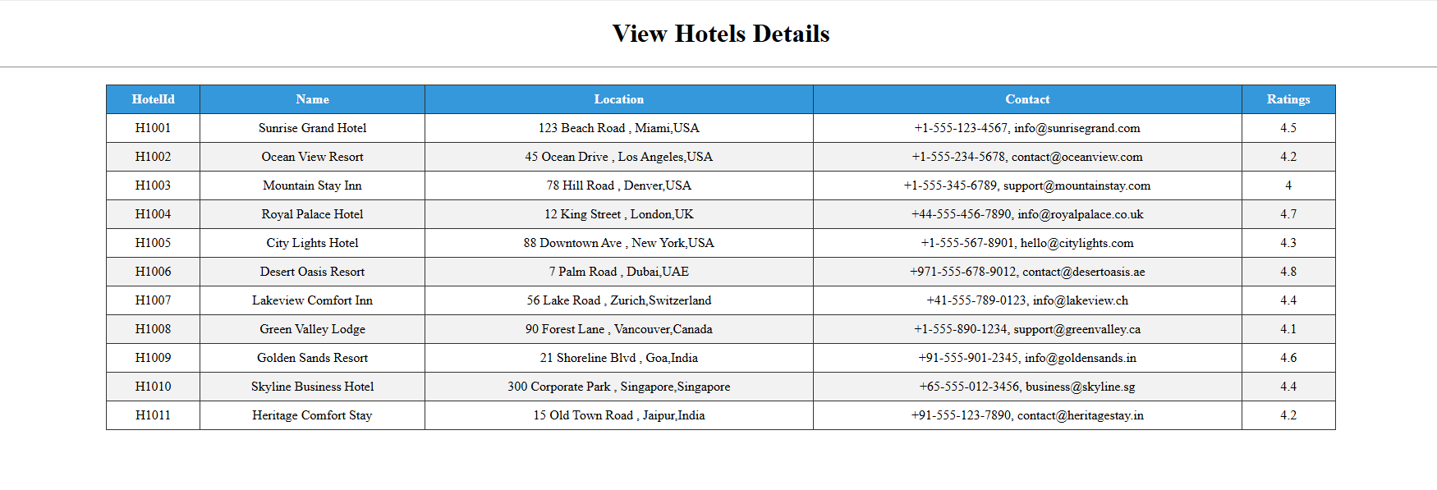
Figure(b): Data fetched from json file

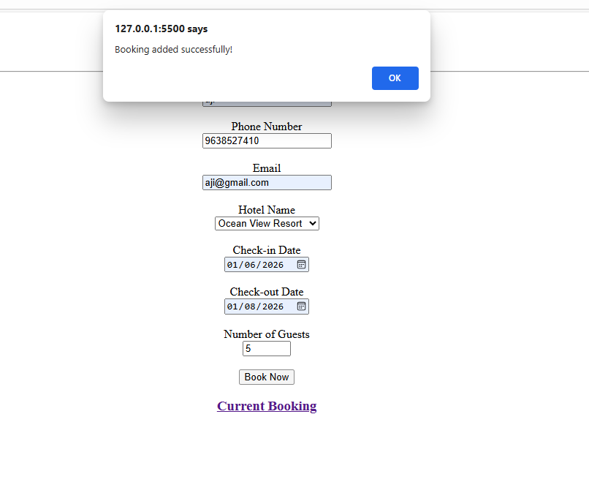
Figure(c): Adding the Customer’s data dynamically

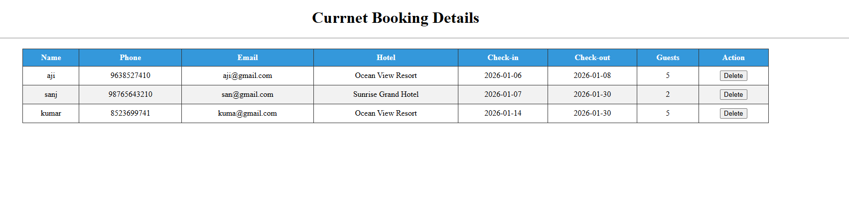
Figure(d): Viewing and deleting the customer data dynamically

Result:
Thus, the JSON representation was successfully completed using JavaScript, demonstrating basic data handling and manipulation by building Hotel management system.

